UNIT 3BCHE NAME:

CARBON CHEMISTRY: Answer all questions

PART A: Multiple Choice Questions. (10 marks)

Q1. A non-cyclic alkane with four carbon atoms has:

- molecular mass of 48
- four carbon to carbon bonds
- eight carbon to hydrogen bonds
D. two isomers

Q2. 1-pentene and 2-pentene are two isomers of C₅H₁₀. A third isomer of C₅H₁₀ is

- 3-pentene
B. cyclopentane
C. methylbutane
D. 1-pentyne

Q3. Methane gas is reacted with excess chlorine in the presence of sunlight. A mixture of chlorinated hydrocarbons is formed. If they are separated by distillation, the first compound to be collected will be

- tetrachloromethane B. trichloromethane

C. dichloromethane D. monochloromethane

Q4. A certain organic compound has a molecular formula of C₄H₈O₂. The compound does NOT cause an acidified potassium dichromate solution to turn green but does liberate a colourless gas on addition of sodium metal. Which one of the following is the correct IUPAC name for this compound?

A. butanone
- 2 - methyl - 2 – propanol
C. butanoic acid
D. butanal

Q5. One litre of gaseous hydrocarbon requires 3 litres of oxygen for its complete combustion and besides water forms 2 litres of carbon dioxide (the volumes of all gases being measured at the same temperature and pressure).

The formula for the hydrocarbon is

A. C₂H₄
B. CH₄
C. C₂H₂
D. C3H6
Q6. Terylene (polyester) is a condensation polymer. Part of the structure of the polymer is
shown.
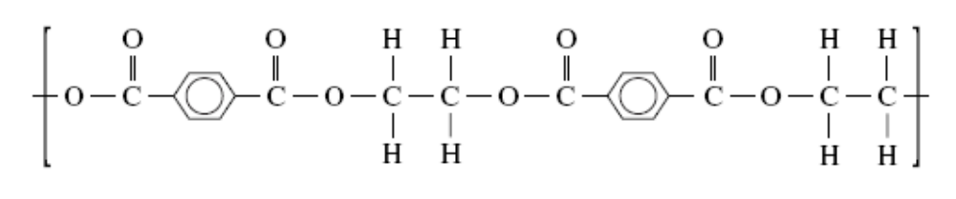
What are the two monomers that form this polymer?

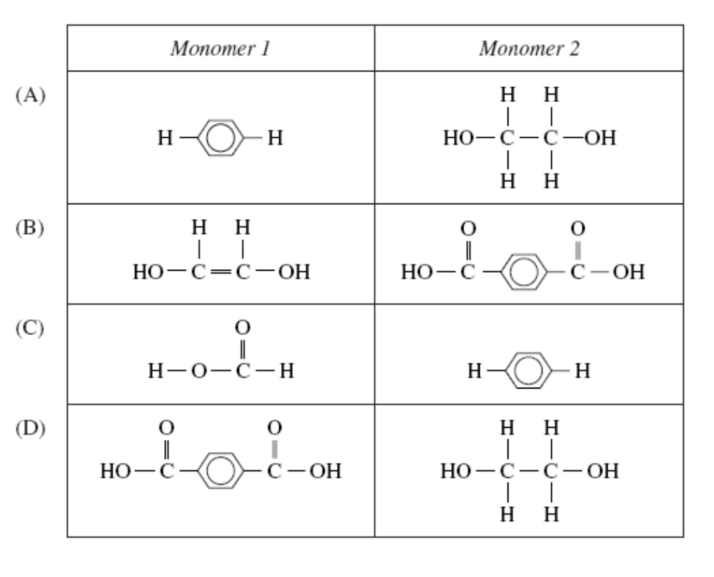
Q7. An organic compound has the structural formula
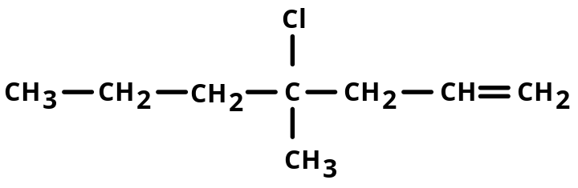

The IUPAC name for this compound is

A. 4 - chloro - 4 - methyl - 1 - heptene
B. 4 - chloro - 4 - methyl - 6 - heptene
C. 4 - chloro - 4 - propyl - 1 - pentene
D. 4 - chloro - 4 - methyl - 1 - heptyne

Q8. The solubilities of tetrachloromethane in the given solvents, in increasing order

(least soluble first, most soluble last) are

A. ethanol; water; chloromethane; octane
B. water; ethanol; chloromethane; octane
C. chloromethane; octane; ethanol; water
D. octane; chloromethane; ethanol; water

Q9. Many carbon compounds contain oxygen.

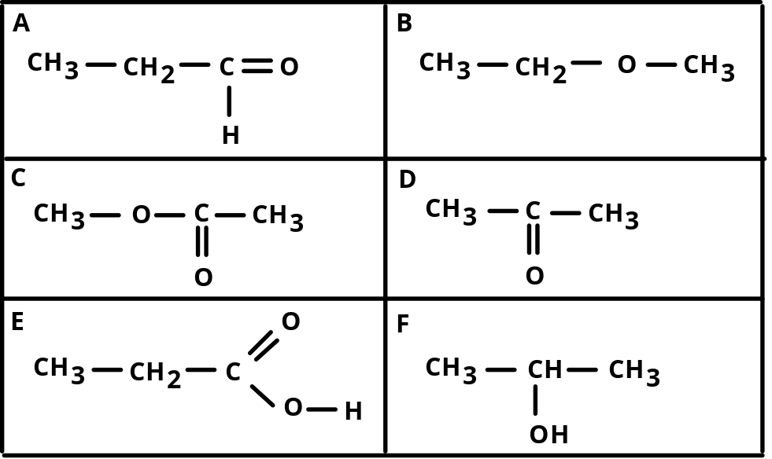

The compound which could be oxidised to form the compound in box D is

A. A B. C C. F D. E

Q10. Bromine reacts with both ethane and ethene. A difference in the two reactions is

A. hydrogen gas is produced with ethane, but not with ethene
B. reaction with ethane is much slower than with ethene.
C. hydrogen bromide gas is produced with ethene, but not with ethane
D. reaction with ethene occurs only in sunlight

END OF PART A

PART B: SHORT ANSWER QUESTIONS (15 marks)

Q11. In the margarine industry, alkenes are often hydrogenated to convert unsaturated oils into solid fats that have a greater proportion of saturated molecules.

A. Using ethene as an example, write an equation for this reaction and state the type of reaction this represents.

Equation:

Type of Reaction:
(2 marks)
B. Describe a test that could be used to confirm that all the ethene has been
converted.

(3 marks)

Q12. Consider the following reaction sequences
Cr₂O₇²⁻/H⁺
Cr₂O₇²⁻/H⁺
isomers
Compound A
C₄H₁₀O
Compound D
C₄H₁₀O
Compound B
C₄H₈O₂
H_{2 (g)}

Compound C
&
a colourless gas
No Reaction

Sodium
Metal
Sodium
Metal
Na₂CO₃
Sodium
Metal
Sodium
Metal
Compound E
C₄H₈O

Draw structural formulae (showing all bonds) and
give the IUPAC (systematic name) of the compounds A, B, C, D and E.

Compound | Structural Formula | IUPAC Name
A

B
C
D
E
(10 marks)

PART C: SHORT ANSWER QUESTIONS (15 marks)

Q13. An organometallic compound containing nickel, carbon, hydrogen and oxygen was analysed as follows

A 3.45 g sample of the compound was combusted in excess oxygen.
It produced 3.44 g of carbon dioxide and 1.06 g of water.

A second sample of the compound, with a mass of 2.33 g, was treated with H₂S and 1.20 g of nickel sulphide was precipitated.

- Determine the empirical formula of the compound.

- 5.32 g of the compound was found to be 3.00 x 10^{─2} mol. Determine the molecular formula of the compound.

(10 marks)
Q13. The table below gives the boiling points for a number of carbon compounds of similar molecular mass.

 | Butane | Propanal | Propanol | Ethanoic  acid | Methyl methanoate
Molar mass | 58 | 58 | 60 | 60 | 60
Boiling  Point (⁰C) | − 0.5 | 48 | 97 | 118 | 32

Account for (explain) the differences in boiling points of the carbon compounds.

You will need to show clear reasoning and diagrams could prove very useful.

(5 marks)

END OF TEST
UNIT3BCHE SOLUTIONS

CARBON CHEMISTRY: Answer all questions

PART A: MULTIPLE CHOICE QUESTIONS (10 marks)

1D | 2B | 3D | 4C | 5A | 6D | 7A | 8B | 9D | 10B

PART B: SHORT ANSWER QUESTIONS (15 marks)
Q11.
A. C₂H₄ + H₂ → C₂H₆ (using a Nickel catalyst)
Addition

B. Add bromine water/solution (Br_{2(aq)/(soln.)})

If hydrogen has been added to all of the double bonds in the compound, it becomes saturated, the brown solution will remain brown. This indicates that there are no double bonds present.

If hydrogen has not added to all of the double bonds in the compound, it remains (is still) unsaturated, the brown solution will turn colourless. This indicates that there are still double bonds present.

Q12.

Compound | Structural Formula | IUPAC Name
A | H H H H  | | | |  H― C― C― C― C― O―H  | | | |  H H H H | Butanol
B | H H H  | | |  H― C ― C ― C ― C = O  | | | |  H H H O ― H | Butanoic acid
C | H H H ― +  | | |  H― C ― C ― C ― C = O Na  | | | |  H H H O  + . . 2-  Na : S :  2 . . | Sodium butanoate
D | H H OH H  | | | |  H― C― C― C ― C ― H  | | | |  H H H H | 2-butanol
E | H H O H  | | ║ |  H― C― C ― C ― C ― H  | | |  H H H | Butanone
(10 marks)
PART C: SHORT ANSWER QUESTIONS (15 marks)
Q13.
Sample 1 [C, H, O, Ni] → CO₂ + H₂O
3.45 g 3.44 g 1.06 g

Sample 2 [C, H, O, Ni] → NiS
2.33 g 1.2 g

m(C) in CO₂ = m(CO₂) x %C in CO₂ = 3.44 x 12.01/(12.01 + 2(16))
= 3.44 x 12.01/44.01 = 0.9387 g

m(H) in H₂O = m(H₂O) x %H in H₂O = 1.06 x 2(1.008)/(2(1.008) + 16)
= 1.06 x 2.016/18.016 = 0.1186 g

m(Ni) in NiS = m(NiS) x %Ni in NiS = 1.2 x 58.68/(58.68 + 32.06)
= 1.2 x 58.68/90.75 = 0.77606 g
%Ni in sample 2 = 0.77606/2.33 = 33.3%
m(Ni) in sample 1 = 3.45 x 33.3% = 1.149 g

m(O) in sample 1 = m[C, H, O, Ni] – m[C, H, Ni]
= 3.45 – [0.9387 + 0.1186 + 1.149]
= 3.35 – 2.20635 = 1.24365 g

 | C | H | O | Ni
m = | 0.9387 | 0.1186 | 1.243 | 1.149
n = m/M | 0.9387/12.01 | 0.1186/1.008 | 1.243/16 | 1.149/58.69
n = | 0.07816 | 0.1176 | 0.0777 | 0.01957
÷ 0.01957 | 3.99 | 6 | 3.97 | 1
Formula | 4 | 6 | 4 | 1

Empirical formula: C₄H₆O₄Ni

B. Empirical formula mass = 4(12.01) + 6(1.008) + 4(16) + 58.68 = 176.778
Relative molecular mass = 5.32 g/3 x 10⁻² = 177
Molecular mass = (empirical formula mass)_{n}
n = molecular mass ÷ empirical formula mass
= 177 ÷ 176.778= 1 (whole number)

Molecular formula = C₄H₆O₄Ni

Q14.
The strength of the intermolecular forces determines the size of the boiling points. These intermolecular forces need to be broken before boiling can take place. Energy is required to break these forces. If the forces are strong more energy is required to break them than if the forces are weak.

In butane there are only C and H atoms bonded together. Since the difference in electronegativity between C and H is very small, the bonding will be non-polar. Dispersion forces are weak forces caused by the attraction of protons in one molecule to the electron clouds in another molecule. Dispersion forces will be the only force holding adjacent molecules together in the liquid butane. These forces are weak and require only a small amount of energy to overcome them, hence the low boiling point of ― 0.5 ⁰C.

In propanal and methyl methanaoate, an O atom is bonded to a C atom. Since the difference in electronegativity between C and O is significant, the bonding here will be polar. Dipole/dipole forces will exist between adjacent molecules along with dispersion forces. These dipole/dipole forces are stronger than the dispersion forces and will require more energy to break than just the dispersion forces between butane molecules, hence the higher boiling points of propanal (48 ⁰C) and
methyl methanoate (32 ⁰C).

In propanol and propanoic acid, an O is bonded to a C but more importantly there is an H atom bonded directly to an O atom. The difference in electronegativity between O an H is significant (O is a very small, very electronegative atom); the ―O―H bond is very polar. Hydrogen bonding (strongest of the intermolecular forces) will exist between adjacent molecules along with dispersion forces. These hydrogen bonds are stronger than the dipole/dipole forces and will require a significant amount of energy to break than the intermolecular forces between propanal and methylmethanoate, hence the very high boiling points of propanol (97 ⁰C) and propanoic acid (118 ⁰C).

The difference between the boiling points of propanol and propanoic acid is that propanol only forms one hydrogen bond per molecule while propanoic acid forms two hydrogen bonds per molecule.

